No matter what kind of walker you are—leisurely, moderate, or
fast paced—you’ll be in good company with our
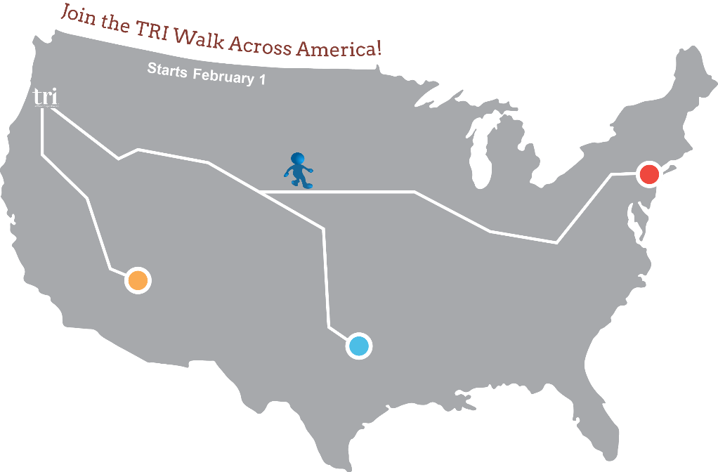
Walk Across America Challenge

Challenge Basics:
- The program is voluntary and starts February 1. It will run for 12 weeks. Our weeks will be from Sunday through Saturday. The full challenge period will be February 1 – April 24, 2016.
- The foundation for the program is based on the 10,000 steps a day concept. There will be three routes to choose from to accommodate different exercise levels. This will be an individual challenge, not a team challenge. Since it is not possible to make it across the full U.S. in 12 weeks by walking, we will be applying a multiplier to each mile to boost people along. Other forms of exercise will count too. We will provide participants with conversion tools to convert other forms of exercise into mileage.
- We have an online mapping system to log your mileage and track your progress across the U.S. throughout the 12 weeks. If you would like, you will also be able to see the progress of others as well!

- Departments can display a map in a hallway to track people’s progress so that those who are not participating can also be involved and encourage those who are Walking Across America.
- There is no cost to participate, but if you would like the chance to win prizes there is a $5 fee. All registration fees will go towards the Governor’s Food Drive, so join in the fun and contribute to a worthy cause at the same time!
- There are some great prizes to win in the Challenge Raffle – everything from water bottles and gift certificates to the Grand Prize worth over $200!
Grand Prize
Stamina Cycle Workstation
that can be used at work
or at home.

Prizes for TRI’s Walk Across America Challenge will be awarded by raffle drawing so that all who are participating for prizes will have an equal chance at winning. The grand prize drawing will include those who completed their routes in 12 weeks.

Additional Resources can be found at the TRI Walk Across America page, or get questions answered by contacting Robbin Bull, 503-838-8562, bullr@wou.edu.

