Rules regarding safe sleep practices:

Provider Training
414-205-0020(14) When a person submits a new application for registration as a family child care provider, OCC shall, prior to approving the registration, receive evidence that the person has:
- Completed OCC approved safe sleep training.

414-205-0020(15) When a registered family child care provider submits a renewal application, OCC shall, prior to approving it, receive evidence from the provider that the provider has:
- Completed OCC approved safe sleep training. If the training is not complete at the time of application, it must be completed by January 1, 2019.

414-205-0020(16) When a person submits a reopen or address change application, OCC shall, shall prior to approving it, receive evidence from the individual that the individual has:
- Completed OCC approved safe sleep training. If the reopen is the result of an address change, the person must complete the OCC approved safe sleep training by January 1, 2019.

Substitutes Training
414-205-0065 Prior to substituting for the provider, a caregiver must:
- Have completed OCC approved safe sleep training.

Program of Activities for Infants and Toddlers and Safe Sleep
414-205-0195
(4) The following safe sleep practices must be followed:
- Each infant shall sleep in a crib, portable crib, bassinet or playpen with a clean, non-absorbent mattress. All cribs, portable cribs, bassinets and playpens must comply with current Consumer Product Safety Commission (CPSC) standards;
- Bassinets may only be used until the infant is able to roll over on their own;
- Each mattress shall:
- Fit snugly; and
- Be covered by a tightly fitting sheet;
- A clean sheet shall be provided for each child;
- Infants must be placed on their backs on a flat surface for sleeping;
- If an infant falls asleep in a place other than their crib, portable crib, bassinet or playpen, the provider must immediately move the infant to an appropriate sleep surface;
- No child shall be routinely left in a crib, portable crib, bassinet or playpen except for sleep or rest;
- There shall be no items in the crib with the infant, except a pacifier (e.g. toys, pillows, stuffed animals, blankets, bumpers);
- Swaddling or other clothing or covering that restricts the child's movement is prohibited;
- Clothing or items that could pose a strangulation hazard (e.g. teething necklaces, pacifier attachments, clothing drawstrings) are prohibited; and
- Car seats are to be used for transportation only. Children who are asleep in a car seat must be removed upon arrival to the center and placed in an appropriate sleep surface.

Food Selection, Storage and Preparation
414-205-0180(12)(b) Bottles shall never be propped. The child or a caregiver shall hold the bottle;
(13) Children of any age shall not be laid down with a bottle.

Supervision
414-205-0110(2) Children out of direct visual contact shall be monitored regularly and frequently and must be in approved activity areas.
(3) There must be sufficient light in any room where children are napping or resting so that caregivers can clearly see each child.
(4) Background noise must not be so loud as to prevent sound supervision.

Importance to children, families and programs:
Safe sleep practices help reduce the risk of sudden unexpected infant death (SUID). Use of safe sleep procedures, continued education of staff/parents/guardians, expanded training, and increased monitoring and observation of infants while they are sleeping are critical to reduce the risk of SUID in child care.

Description of how it is different from previous rules:
Rules written before September 30, 2018 require infants have a crib, playpen, or portable crib for sleeping, and infants are laid on their back for sleep. New rules expand on safe sleep guidelines by not allowing anything in the crib with infants, except a pacifier, and are more explicit around strangulation hazards, flat sleep surfaces and moving infants out of car seats, swings, and other equipment if the infant falls asleep in them.

Additional information:
Safe sleep rules are intended for infants. Rules define infants as up to 12 months in age.

Providers must remain on the same floor as sleeping child care children in order to be in compliance with sight and/or sound supervision rules.

Blankets are not allowed in infant cribs or play pens. This includes hanging blankets over the side of the crib or playpen. Instead of using blankets, you can use sleep sacks as long as they do not swaddle the infant, restricting their movement.

Infants less than one year of age must be placed to sleep on their backs. When, in the opinion of the infant’s licensed health care provider, an infant requires alternative sleep positions, or special sleep arrangements, you must ask for an exception to the rule and provide a medical statement from the health care provider.

When infants can easily rollover, they shall initially be placed to sleep on their backs, but shall be allowed to adopt whatever position they prefer for sleep. The American Academy of Pediatrics recommends that infants are placed on their back to sleep, but when infants can easily turn over from their back to their stomach, they may sleep in whatever position they prefer.

All infants must be closely monitored while sleeping. You must visually check on infants regularly to verify they are not in any sort of distress. Monitors do not take the place of visual checks and will only alert you of loud sound, but will not alert you of breathing issues. The lighting in the room must allow you to see the infant’s face, to view the color of the infant’s skin, and to check on the infant’s breathing. When an infant is sleeping in a room separate from where other care is provided, the door must stay open to remain within sound of the infant.

You should take steps to keep infants from overheating by regulating the room temperature, and not over-dressing the infant. You must conduct physical checks of the infant to ensure the infant is not overheated.

A copy of the safe sleeping guide is available from your licensing specialist or by accessing the following website: http://safetosleep.nichd.nih.gov .

For more information on crib safety guidelines see Consumer Product Safety Commission (CPSC): www.cpsc.gov.

Examples of acceptable types of sleep sacks are:

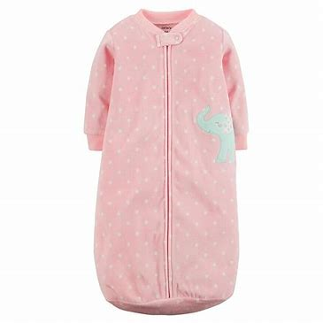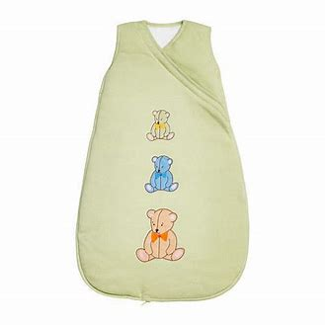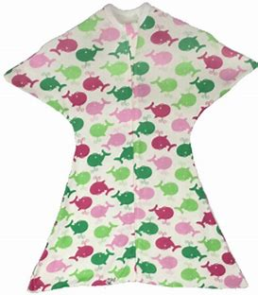
Sleeveless Arms and legs can freely move

These types of sleep sack are not allowed:

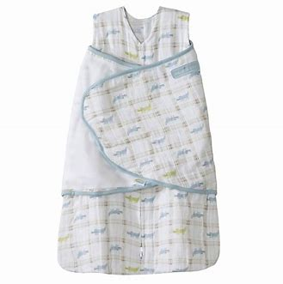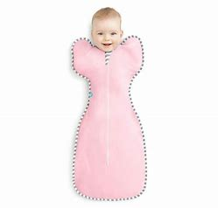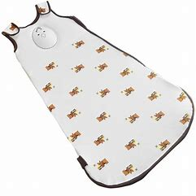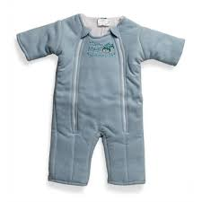

Restricts arm movement Weighted on the chest Weighted

This document is designed to assist programs in understanding some of the revised regulations. Please refer to the revised rule book for a complete set of regulations and specific rule language.

