WALK ACROSS AMERICA IN 10 EASY STEPS
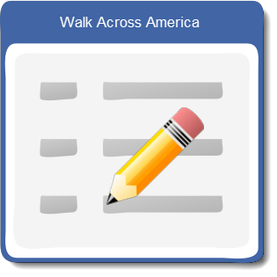
- Fill out Registration.

- Give registration to Robbin Bull,
bullr@wou.edu, Todd Hall Rm 236.

- Decide which route to take.
Miami, FL?
Chicago, IL?
Denver, CO?
- Donate $5 to Governor’s Food Drive & have a chance to win prizes in Walk Across America. (You do not have to donate to participate.)

- Encourage family and friends to join you.

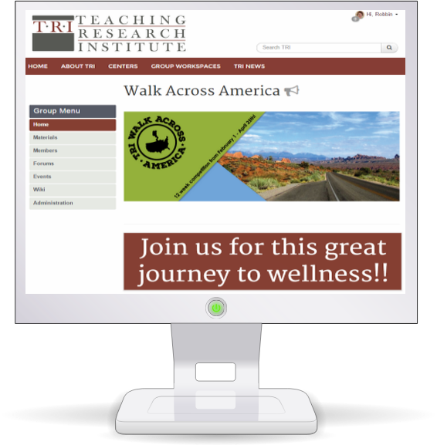
- Review the Walk Across America (WAM) Challenge details on the program resources page.

- Come by the Health Fair at Todd Hall, 2nd floor East Wing, Rm 245, January 27, 12:00 – 1:30 for a Walk Across America(WAM) orientation, pick up health and wellness in resources, and much more!

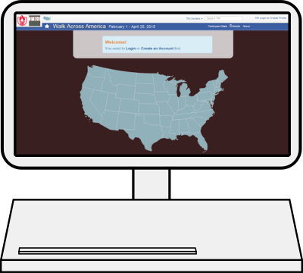
- Get online and register to track mileage at:
http://triwou.org/wam.

(Site available February 1, 2016)
- February 1 Start Walking/Running/Exercising!

10. Log those miles using your electronic devices from anywhere!
